**Project Design Phase-II**

**Data Flow Diagram & User Stories**

|  |  |
| --- | --- |
| Date | 26 June 2025 |
| Team ID | LTVIP2025TMID43759 |
| Project Name | Hematovision – Advanced Blood Cell  Classification using Transfer Learning |
| Maximum Marks | 4 Marks |

**Data Flow Diagrams:**

A Data Flow Diagram (DFD) is a traditional visual representation of the information flows within a system. A neat and clear DFD can depict the right amount of the system requirement graphically. It shows how data enters and leaves the system, what changes the information, and where data is stored.

**Example: 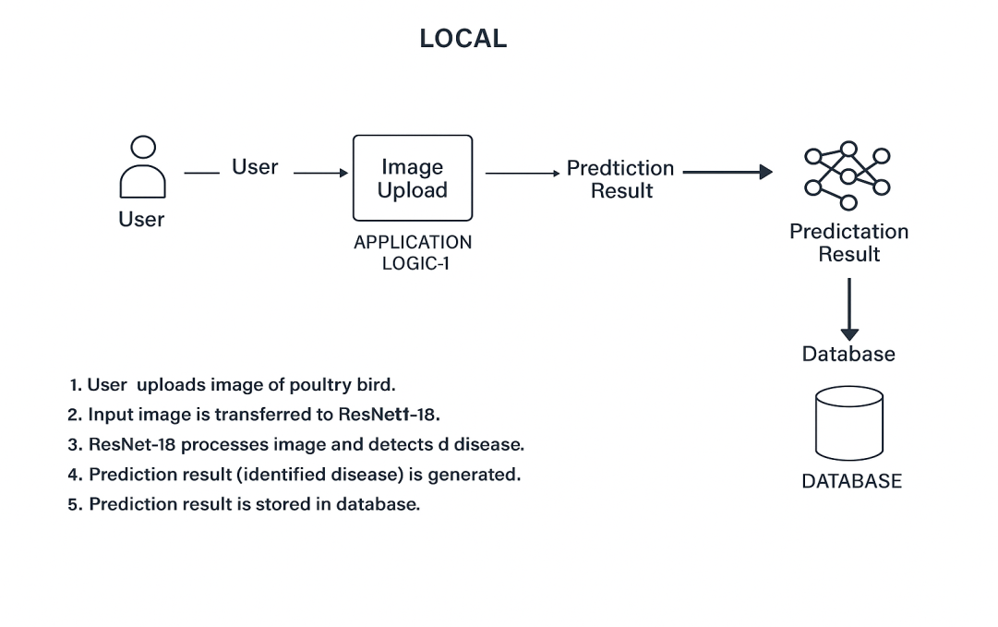(Simplified)**

User uploads image of Blood

cell then it is transferred to MobileNetV2.It processes image and detects the type of blood cell.Prediction result(identified type) is generated.

and stored in database.

**User Stories**

Use the below template to list all the user stories for the product.

| **User Type** | **Functional Requirement (Epic)** | **User Story Number** | **User Story / Task** | **Acceptance criteria** | **Priority** | **Release** |
| --- | --- | --- | --- | --- | --- | --- |
| Customer (Web user) | Image Upload | USN-1 | As a user, I can upload a Blood Cell image from my system. | Image file (JPG/PNG) is  accepted and previewed. | High | Sprint-1 |
|  | Image Upload | USN-2 | As a user, I receive an error if I upload an  invalid file. | Invalid file types are  rejected with a message. | Medium | Sprint-1 |
|  | Blood Cell Type Detection | USN-3 | As a user, I can get a prediction for uploaded  image. | Model output is shown  with confidence score. | Higj | Sprint-2 |
|  | Prediction Result Display | USN-4 | As a user, I can view the Blood celltype and  confidence level. | Blood Cell type and  percentage is displayed. | High | Sprint-2 |
|  | History Tracking  (Optional) | USN-5 | As a user, I can view my previous uploaded  images and results. | History is shown in tabular  or card form. | Low | Sprint-1 |
| Administrator | Model  Management | USN-6 | As an admin, I can update the model or  re-deploy it when a better version is read. | New model file can be  uploaded into the system. | Medium | Sprint-2 |
|  | Dataset  Expansion  (Optional) | USN-7 | As an admin, I can add new images to retrain  or improve the model. | New image added to  training dataset folder. | Low | Sprint-2 |